Experiment 3
Online bus ticket booking system
Aim
To develop an online Bus Ticket Booking System that allows users to register, log in, search for buses, select seats, book tickets, and cancel bookings. The admin can manage bus details, categories, users, comments, and booking reports.
Procedure
- Create a webpage using HTML for bus ticket booking.
- Add user registration and login forms.
- Provide options to search buses by source, destination, and travel date.
- Display bus types, ticket prices, and available seats.
- Allow users to enter passenger details and book or cancel tickets.
- Provide a comments section for user feedback.
- Add an admin section to manage buses, users, schedules, and reports.
- Test the webpage to verify the booking process.
Sample Code

<!DOCTYPE html>
<html>
<head>
<title>Bus Ticket Booking</title>
</head>
<body>
<h1>Online Bus Ticket Booking</h1>

<h2>User Login / Registration</h2>
<input type="text" placeholder="Username">
<input type="password" placeholder="Password">
<button>Login</button>
<button>Register</button>

<h2>Search Bus</h2>
<input type="text" id="from" placeholder="From">
<input type="text" id="to" placeholder="To">
<input type="date" id="date">
<button onclick="searchBus()">Search</button>

<p id="result"></p>

<h2>Book Ticket</h2>
<input type="text" id="passenger" placeholder="Passenger Name">
<select id="bus">
<option>Volvo</option>
<option>Sleeper Coach</option>
<option>AC Coach</option>
</select>
<button onclick="bookTicket()">Book Ticket</button>
<button onclick="cancelTicket()">Cancel Ticket</button>

<p id="ticket"></p>

<h2>Comments</h2>
<textarea id="comment" placeholder="Write your feedback"></textarea>
<button onclick="addComment()">Submit</button>
<p id="feedback"></p>

<h2>Admin Panel</h2>
<p>Manage buses, users, schedules and reports.</p>

<script>
function searchBus() {
let from = document.getElementById("from").value;
let to = document.getElementById("to").value;

if (!from || !to) {
alert("Enter source and destination.");
return;
}

document.getElementById("result").innerHTML =
"Bus available: " + from + " to " + to;
}

function bookTicket() {
let name = document.getElementById("passenger").value;
let bus = document.getElementById("bus").value;

if (!name) {
alert("Enter passenger name.");
return;
}

document.getElementById("ticket").innerHTML =
"Ticket booked for " + name + " - " + bus;
}

function cancelTicket() {
document.getElementById("ticket").innerHTML =
"Ticket cancelled.";
}

function addComment() {
document.getElementById("feedback").textContent =
document.getElementById("comment").value;
}
</script>
</body>
</html>

Output
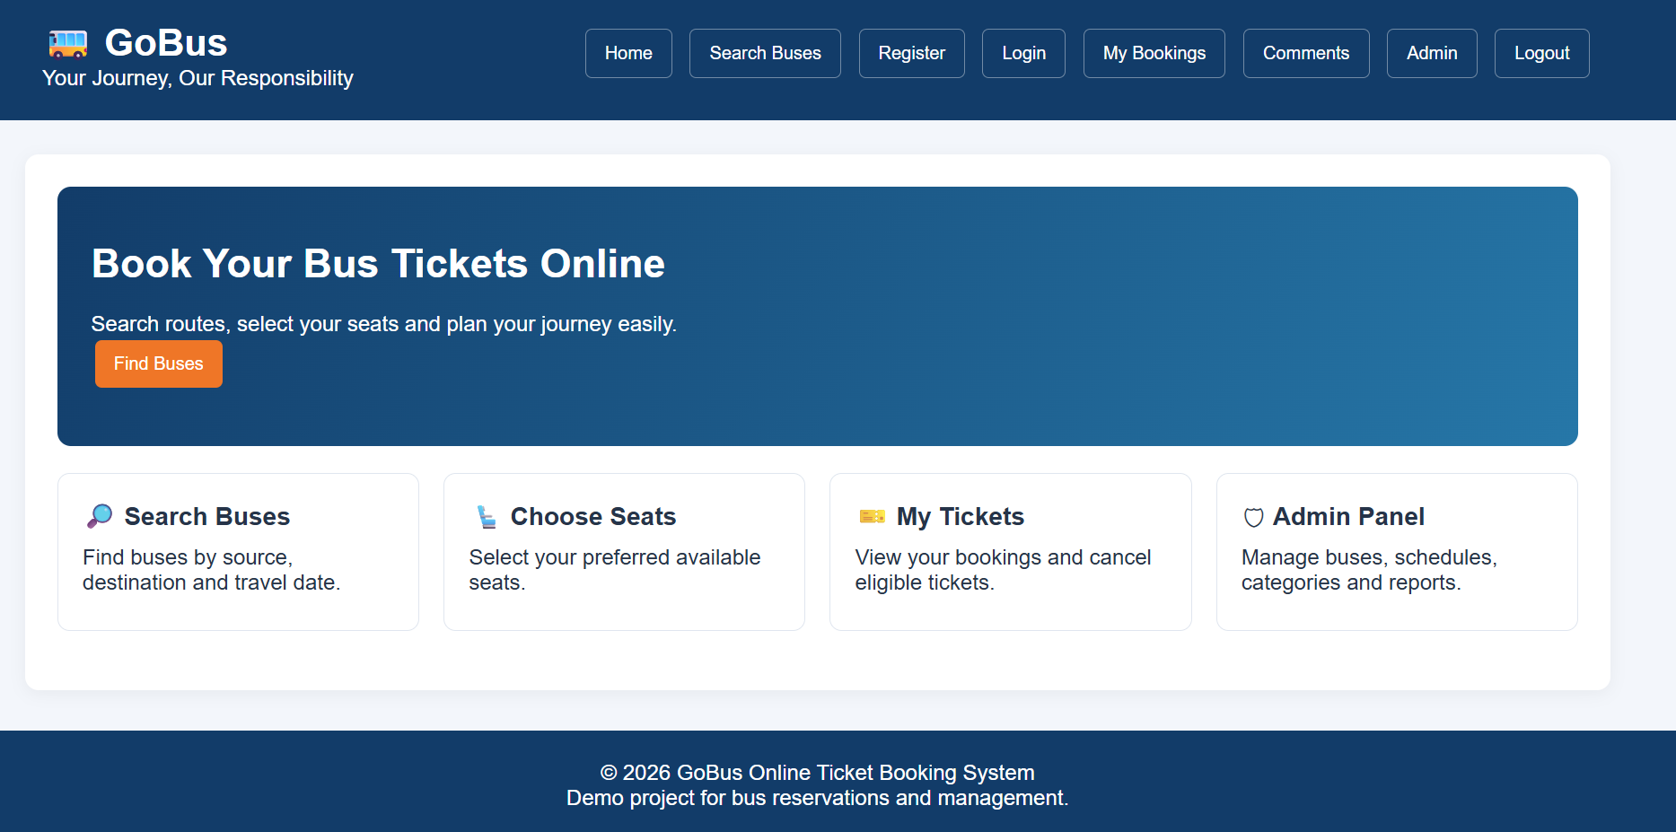

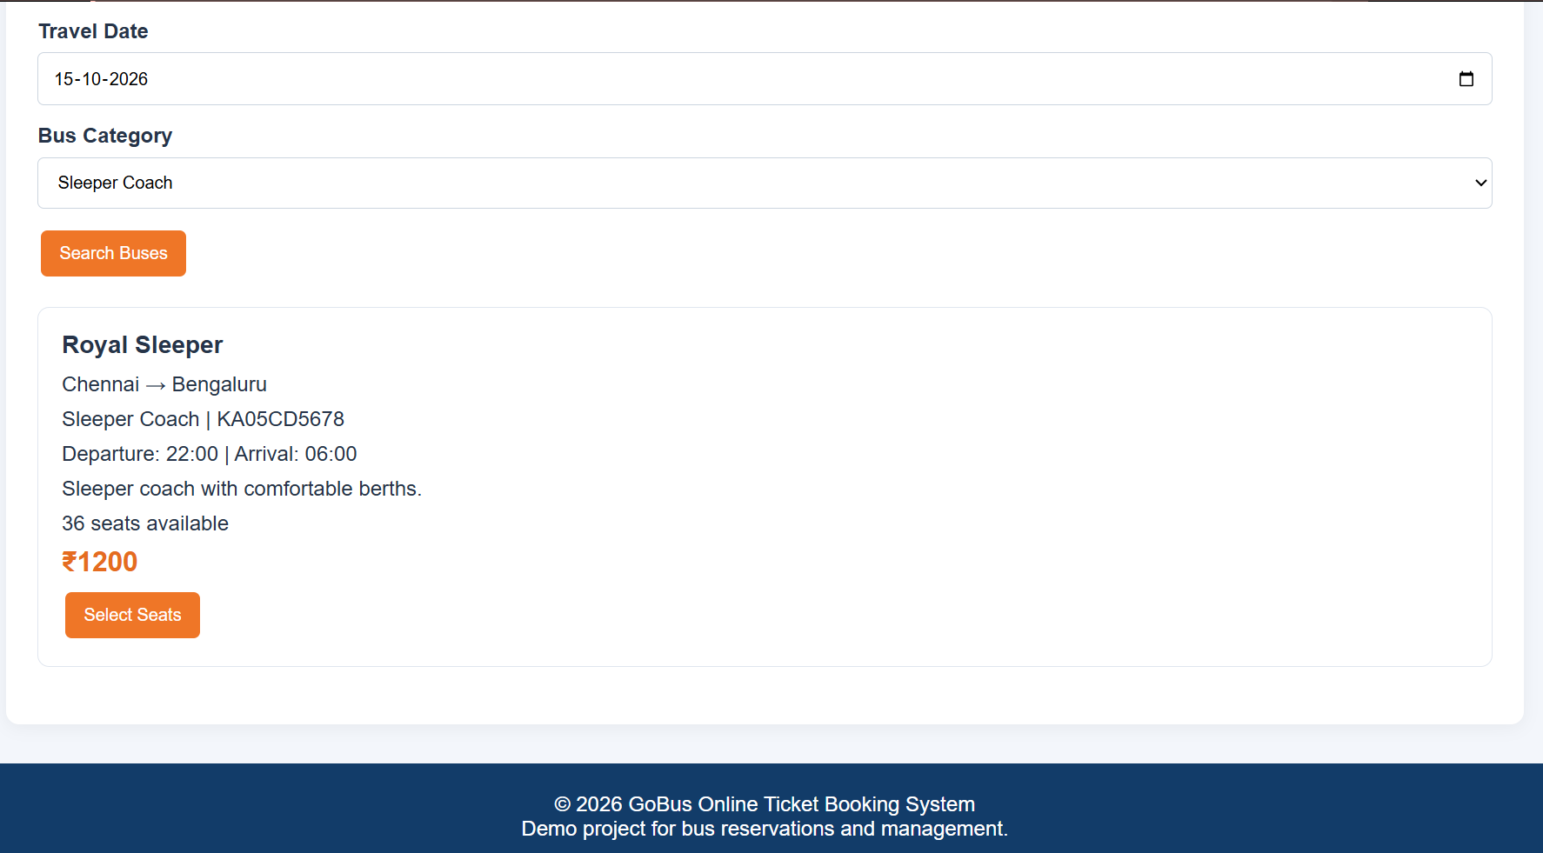

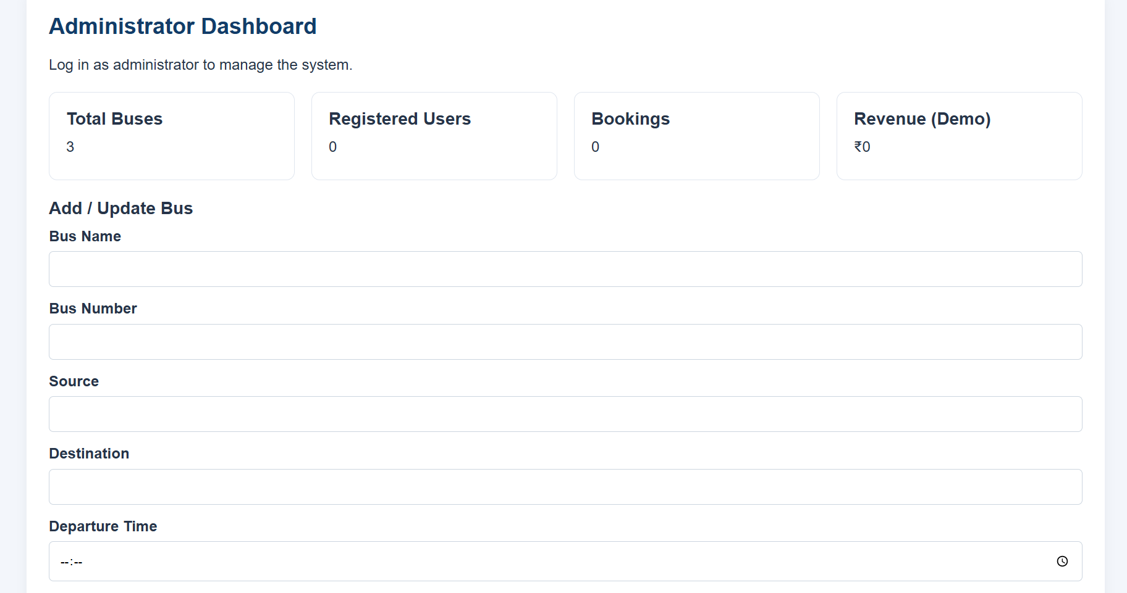

Result
The Online Bus Ticket Booking website was created successfully. Users can enter their journey details, select a bus type, book or cancel a ticket, and submit feedback. The system demonstrates basic booking functions, while actual seat availability, secure payments, user authentication, and report generation require a backend and database.

